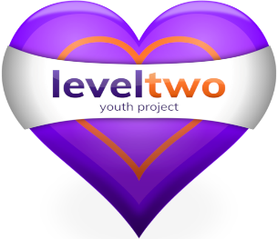
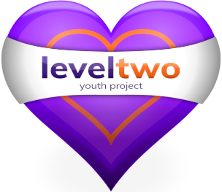
Felixstowe Youth Development Group

54 Cobbold Road, Felixstowe, Suffolk, IP11 7EL

Tel: 07724356723 Email: shezhopkins@leveltwo.org

www.leveltwo.org
Registered Charity No. 1102380 Registered Company No. 04125056

Dear Parent / Carer,
Occasionally it may be necessary for our staff to transport young people in their own car. This is done under strict guidelines. These include:-
- Permission has been given by the Project Manager.
- There is good reason for carrying out this action.
- The staff member has business insurance on their vehicle.
- The staff member must let the project manager know once the young person has been returned home.
- Parental permission must be given for each trip / visit.
- If possible there should be 2 members of staff in the car / bus.
- A copy of this form must be kept on file in the Office.
I give permission for my child ______________________________________________
To travel by car with (Staff members name) ____Shez Hopkins____________________
Are there any dietary / allergic reactions / additional needs we should aware of? Yes No (If yes please state below)
______________________________________________________________________

Parent signature_________________________________________________________

Date____________________________________

Staff / Driver signature_____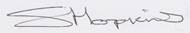________________________

Date______07/11/2025________________________________

Yours sincerely,
Shez Hopkins
Project Manager





