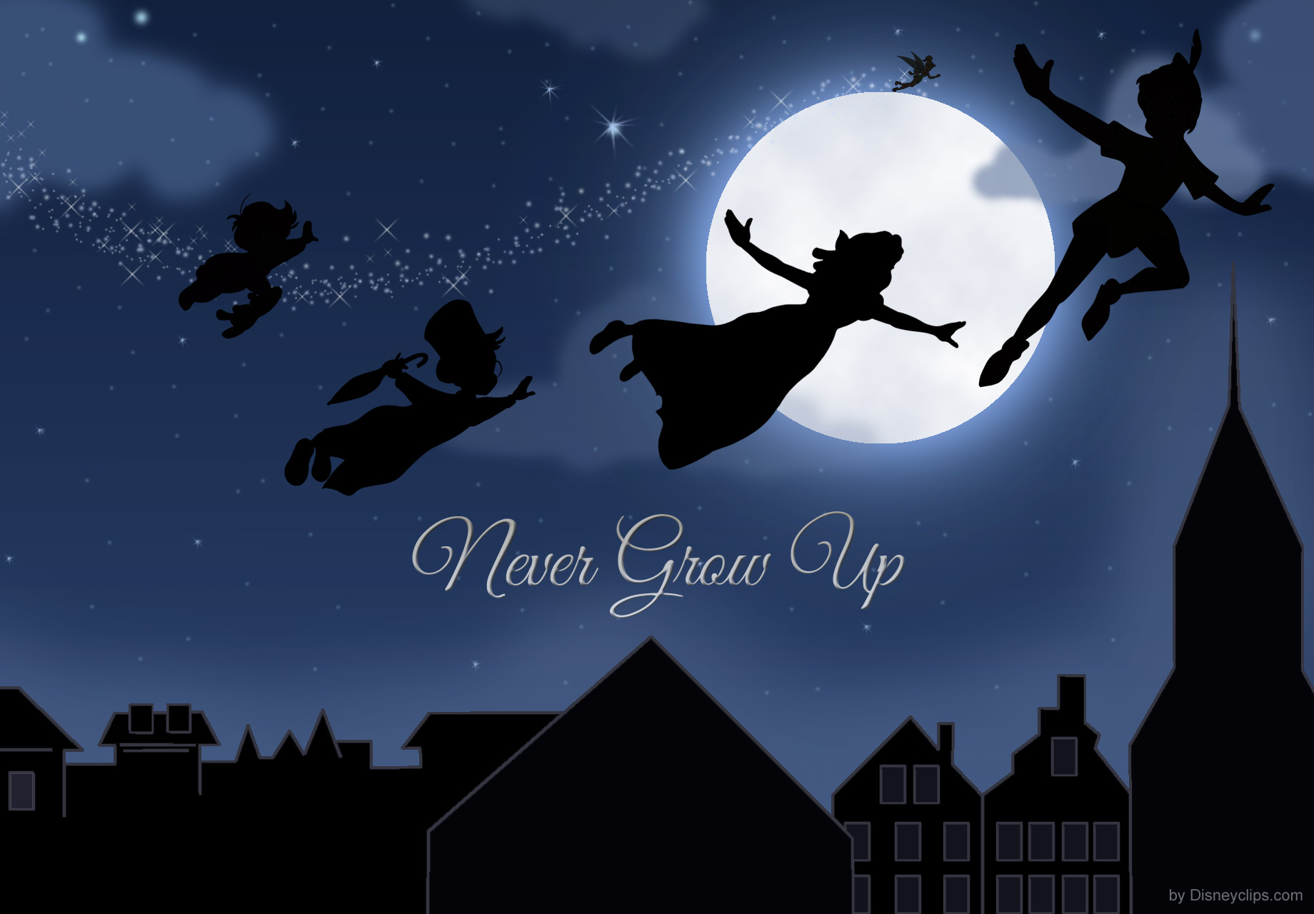

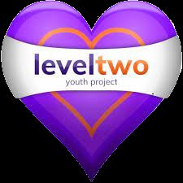
Level Two Youth project in conjunction with arts award

Proudly presents
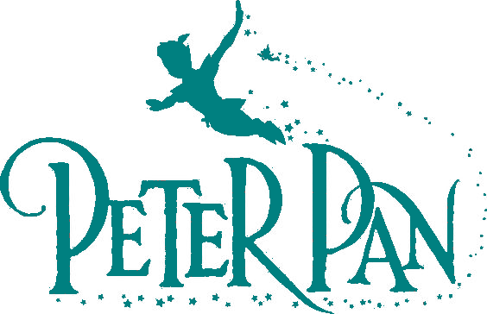
A six-week summer project for young people to dance, act and sing, while making friends and gaining a nationally recognised qualification

Contact Level Two via email at fydgleveltwo@gmail.com to register your interest & for more info.

