Felixstowe Youth Development Group
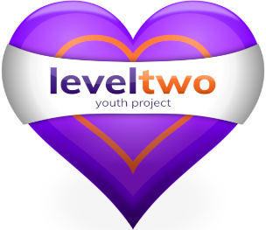

Policy Number 34

TRANSPORTING YOUNG PEOPLE POLICY

(Issue 8 July 2022)

Approved by Trustees__20th September 2022____

Registered Charity Number: 1102380
Registered Address: 2nd Fl0or, 54 Cobbold Road, Felixstowe IP11 7EL

Use of private cars
- Level Two staff (including volunteers) are only permitted to transport young people on Level Two business in extreme circumstances; & after all alternatives have been exhausted.
- If a young person is transported the driver must have business insurance on their cover; & have been given permission by the Project Manager / Deputy Project Manager.
- Wherever possible 2 adults must be in the vehicle if one or more young people are being transported.
- The driver must have the young person’s parent/carer consent for the journey in question. Level Two will seek consent in writing. (See appendix (a)) Verbal consent will only be acceptable in extreme circumstances.
- The driver is responsible for ensuring that young people sit in the rear of the vehicle & are wearing a seatbelt whilst the vehicle is in motion.
- The driver is also responsible for ensuring the vehicle has a current MOT & is road worthy.
Use of minibus transport
- Level Two staff with suitable experience of driving minibuses will be permitted to drive Level Two approved vehicles. The approved vehicles may be a Level Two owned minibus or a minibus hired from a commercial outlet.
- Drivers of vehicles with more than 9 seats must be over the age of 21yrs & have a minimum of 2yrs driving experience.
- A copy of their driving licence & DVLA Code will be kept by the Administrative Assistant for checking with the DVLA on each occasion it is used. Obtaining the DVLA Code is the responsibility of the driver. The code is then passed to the Level Two administrator. DVLA Driver Codes currently last for 4wks, after which time a new code is needed
- There must be a minimum of two adults in the minibus, including the driver, when young people are being transported. The young people must have their parents consent for the journey in question.
- Level Two will seek consent in writing for planned activities & in the unlikely event of a minibus being used for an unplanned activity, parent’s / carers telephone consent will be sought.
- The driver must ensure that the young people are wearing seatbelts at all times the vehicle is in motion.
- The responsibility for maintaining the minibuses in a legal and roadworthy condition (including insurance certificates, MOT and minibus permits) rests with Level Two Youth Project.

