Felixstowe Youth Development Group
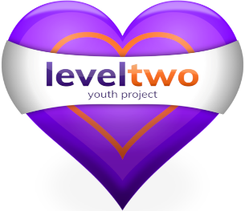

Policy Number 25

YOUTH PARTICIPATION POLICY

(Issue 10 – Revised February 2022)

Approved by Trustees _March 2022____________________

Registered Charity Number: 1102380

Registered Address: 2nd Floor, 54 Cobbold Road, Felixstowe, IP11 7EL

LEVEL TWO YOUTH PROJECT

YOUTH PARTICIPATION POLICY

At Level Two we recognise the importance of enabling young people to have a voice & share their opinions & views. This right is enshrined in Article 12 of the United Nations Convention on the Rights of the Child

We believe all young people can make a valuable contribution and we empower them to have their say. Staff encourage young people to be involved with decision making, planning, evaluation of services & choices of activities we offer. This involves active listening, honesty & trust.

We believe young people have the right to choose how they spend their leisure time. Our services are influenced by ideas and suggestions made by young people in conversations with youth workers, in formal meetings and via feedback. All our services focus on & are aimed at improving the life chances of a young person, taking into account their emotional, mental & physical well-being needs.

We actively seek to promote the role of Level Two Youth Ambassadors, ideally two young people of different gender. Youth Ambassadors meet regularly with Trustees, gather feedback and ideas from other young people & represent the Project at events & functions.

See Appendix 1. Harts Model – we aim to be always between 2 & 3 on this scale.

Appendix 1.

