Felixstowe Youth Development Group
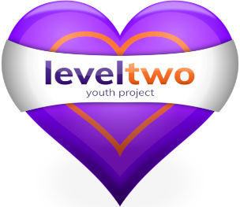

Policy Number 7

EQUALITY AND DIVERSITY POLICY AND PROCEDURES

(Issue 10 – Revised February 2022)

Approved by Trustees _15th February 2022____________________
Chair of Felixstowe Youth Development Group

Registered Charity Number: 1102380

Registered Address: 2nd Floor, 54 Cobbold Road, Felixstowe IP11 7EL

FELIXSTOWE YOUTH DEVELOPMENT GROUP
EQUALITY AND DIVERSITY POLICY
INTRODUCTION
This Policy seeks to promote and uphold the principles of equality, diversity, fairness and inclusion within our employment practices, service design and delivery and procurement.
The Policy is in line with Felixstowe Youth Development Group's (FYDG) duties and responsibilities under the Equality Act 2010. FYDG will not tolerate discrimination, harassment or victimisation & will strive to promote equality of opportunity.
SCOPE
This policy applies to trustees, employees, job applicants, service users, contractors and volunteers. See Tool Kit for more detail. We will treat everyone with the same attention, courtesy & respect regardless of:-
- Age
- Disability
- Race
- Religion or belief
- Sex/Gender
- Marriage and civil partnership
- Gender identity
- Pregnancy and maternity
- Sexual orientation

OUR COMMITMENT
We are committed to promoting equality by
- Recognising, valuing and respecting diversity
- Actively challenge discrimination & nurturing a culture that creates safety to challenge
- Aiming to ensure that our services are accessible to all who meet any relevant criteria
- Having appropriate recruitment and employment procedures
- Investigating any complaints
- Ensuring that no form of intimidation, bullying or harassment is tolerated
- Taking all reasonable steps to ensure we do not unlawfully discriminate

ACTIVITIES
In all our activities we will
- Give due regard to equality & diversity when reviewing existing & developing new strategies, policies, services & functions to ensure that we provide excellent accessible services & fair working practices
- Engage and involve interested groups and individuals in our decision making processes
- Deal with all complaints of discrimination , harassment or victimisation promptly and with sensitivity to all those involved
- Take all opportunities to advance equality of opportunity

REVIEW: - This policy will be reviewed every 3 years.

Tool Kit
THE EQUALITY ACT 2010

The Equality Act 2010 identifies that it is unlawful to discriminate against people because of nine areas termed in the legislation as 'Protected Characteristics'.

These nine 'Protected Characteristics' are:

- age
- disability
- gender reassignment
- marriage and civil partnership
- pregnancy and maternity
- race
- religion or belief
- sex/gender
- sexual orientation

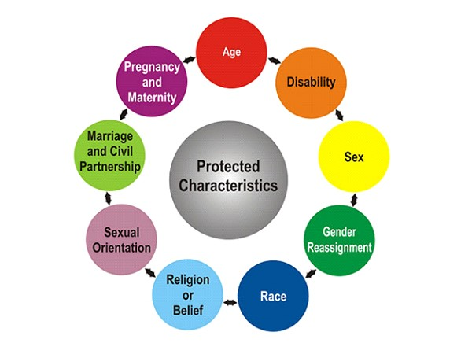

Types of Discrimination are identified under four main headings:
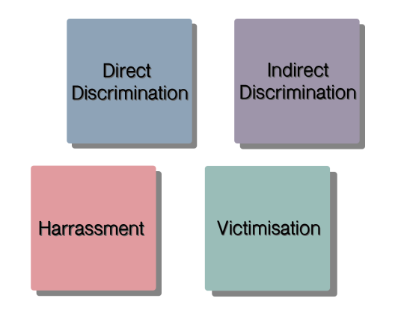

- Not all unfair treatment is unlawful discrimination under the Equality Act

- It is only unlawful discrimination if you’re treated differently because of a Protected Characteristic

- It doesn’t matter if the person treating you differently didn’t mean to discriminate against you
or
- if they didn’t know they were discriminating

- Direct Discrimination
Direct discrimination occurs when someone is treated less favourably than another person because of a protected characteristic. You need to compare your treatment with the treatment of someone else who doesn't have the same protected characteristic as you. The Equality Act calls this person a Comparator.

- Indirect Discrimination
Indirect discrimination occurs when there is a rule or policy that applies to everyone but disadvantages a person with a particular protected characteristic.

- Harassment
Harassment occurs when there is behaviour that is deemed offensive by the recipient. You can complain of behaviour that you find offensive even if it is not directed at you. For behaviour to count as harassment in equality law, it has to be one of three types:
- unwanted behaviour related to the protected characteristics listed in the Equality Act 2010
- sexual harassment
- less favourable treatment because of submission to or rejection of previous sex or gender reassignment harassment.
Harassment by a Third Party occurs when an employer is subjecting their employee to harassment where:
- a third party subjects the employee to harassment in the course of the employee’s employment
- the employer fails to take reasonably practicable steps to protect their employee from that third-party harassment
- the harassment is known to have occurred on at least two previous occasions
- the third-party harasser does not have to be the same individual on each occasion or employed by the same organisation.

- Victimisation
Victimisation occurs when someone is treated badly because they have made [or supported] a complaint or grievance under the Equality Act 2010.

EQUALITY ACT 2010

Adherence to this legislation applies to any employer, charitable or community sector organisation, trustee of an organisation, employee, job applicant, service user (young person), contractor or volunteer.

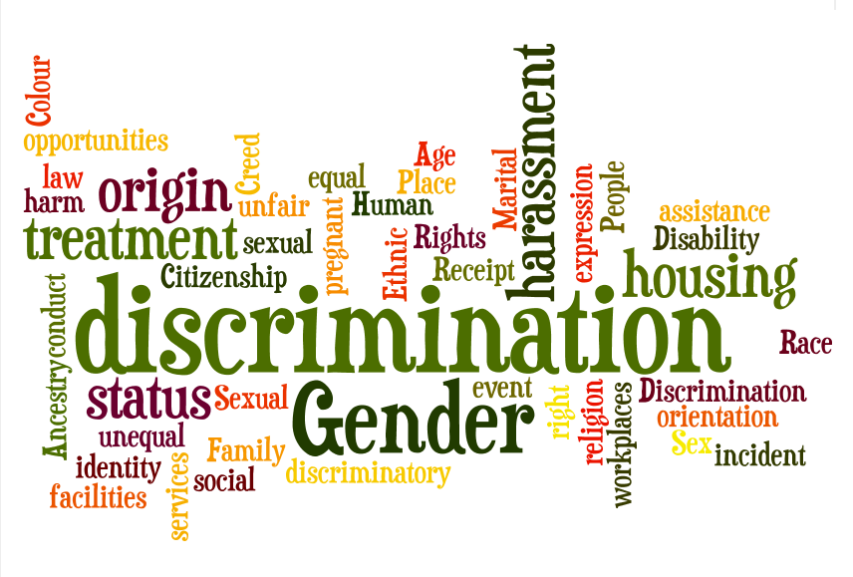

The following nine sections provide examples of discrimination under the 'Protected Characteristics'.
Age
Age discrimination is where you are treated unfairly because of your age or because you are part of a particular age group e.g. 25 year olds, under 30s, young adults, pensioners, over 70s.
Direct discrimination
- You are denied the opportunity to represent your company at a conference because your manager thinks that despite you having the necessary knowledge and skills you look 'too young' and wants a more mature looking colleague to attend.

- You are denied term-time working because you are ‘too old’ and have grandchildren not children.

Indirect discrimination
- A training course is offered only to recent graduates. This requirement may mean older employees are not able to take up the opportunity.

- An optician allows customers to pay for their glasses in instalments provided they are in permanent employment. This could indirectly discriminate against older people who are retired and not in employment.
Harassment
- Offensive jokes or comments are made about your age and the age of your partner who is 15 years older than you.

- During a training session for staff on new office software, the trainer keeps commenting how slow an older student is at learning to use the software. The student finds this harassment related to his age distressing.

Victimisation
- You are passed over for a promotion that was due to you because you supported a colleague’s complaint of age discrimination.

Exception examples
- It may occasionally be necessary to confirm if someone is over 18 to comply with other UK Legislation e.g. selling alcohol in a bar or driving and operating machinery.
Disability
A disability is a physical or mental condition which has long-term and substantial effect on your daily life.
Cancer, HIV, multiple sclerosis, severe disfigurement or certified blindness are automatically treated as a disability under the Equality Act.

Direct discrimination
- You are denied access to the newly carpeted area of a public cafe because one of your group has cerebral palsy and the owner believes they may spill their drink or food.

- During an interview, a job applicant tells the potential employer that he has multiple sclerosis. He is the best candidate for the job but is not given it because the employer assumes he will require a lot of time off sick.
N.B. It is generally unlawful to ask questions about disability and health before you make a job offer.
Indirect discrimination
- A local Leisure Centre produces an information leaflet on times and costs of sessions but does not produce an easy-to-read version. The duty manager tells you this is in order to save money as only one or two people would want it. The Leisure Centre is not seen as making 'reasonable adjustments' to ensure that partially-sighted customers have the information which is available to sighted customers.
- A job advert for an office administrator states that all applicants must hold a current driving licence. This puts people with epilepsy at a disadvantage and would only be acceptable if the job was a delivery driver, bus driver, etc.
Harassment
- Colleagues are making offensive jokes or comments about your disability which you find humiliating, frightening or degrading.
N.B. It can still be harassment (even if the person harassing you means well) when, during a group session, your tutor repeatedly asks if you are ok and 'do you need a break to take your injection yet?'.
Victimisation
- A person with a mental disability sues a local corner shop because the owner frequently makes hurtful remarks about his disability. Because of this the shop owner bars the man from the shop altogether.

- An employee with severe mobility issues makes a complaint that 'reasonable adjustment' has not been made for her to have a parking space near the office entrance. The company advises that it only gives these places to senior management.
Race
Race discrimination is when you're treated unfairly because of one or more of the following:
- colour
- nationality (citizenship by birth)
- ethnic origin (based on your language, geographical origin)
- national origin (e.g. you are Romanian by origin but have British citizenship)
Direct discrimination -
- You do not get promoted because of your colour. Your employer says that it is because ‘customers may object’.

- A letting agency does not rent a flat to you because of your race.

Indirect discrimination
- An employer insists that all employees should have English as their first language even though the job does not involve direct interaction with clients.

- A hairdresser refuses to employ you as you wear a hijab and the employer wants all stylists to have their hair styled and on view to customers.

Harassment
- A young British Asian man is called racist names by his colleagues, they say it is just banter.

Victimisation
- The young British Asian man who is being harassed makes a formal complaint to his manager. His manager says that unless he drops the complaint, he will lose his job.

Race discrimination by association
- An employer turns down your application for the job even though you are the best person for the position because your partner belongs to a race that the employer is biased against.

Religion or belief
‘Religion’ refers to all major religions such as Christianity, Buddhism, Islam, Judaism, Hinduism and Sikhism as well as less widely practiced religions such as Scientology, Paganism and Rastafarianism amongst others.

You are protected against discrimination if you belong to any one of the religions and you are also protected against discrimination if you do not belong to any religion or do not have any religious beliefs – for example, if you are an Atheist.

Direct discrimination
- A job advertisement specifically mentions that only applicants of one particular religion may apply.

- You are refused a bank loan because you are Jewish.

Indirect discrimination
- A pub landlord refuses to serve you because you are wearing a headscarf and he thinks you are a Muslim, even though you're not.

- You are Jewish and you finish work early on a Friday to observe the Sabbath. Your manager moves the team meeting from a Wednesday afternoon to a Friday afternoon and as a result you are now unable to attend team meetings.

Discrimination by association
- You and your friend are both refused entry to a nightclub because the friend you are with is a Rastafarian.

Harassment
- You are teased and humiliated at work. You are a Christian and always refuse to work optional overtime on a Sunday so you can attend church.

Victimisation
- You are treated unfairly because you supported a colleague who put in a complaint that they were not allowed to take holiday to celebrate their main religious festival.

Sex/Gender
Fairness for both sexes is a legal requirement in all workplaces. Under this clause, employers must treat men and women the same with regards to all aspects of employment including recruiting, training, salary, promotion, dismissal and severance pay.

Direct discrimination
- A female employee at a media centre receives a lower salary than her male colleague. She is equally qualified and holds the same post in the organisation.

- A nightclub charges men an entrance fee but does not charge women.

Indirect discrimination
- A job advertisement states that the applicant must be 6'2" in height.

- An employer changes the shift times worked in their organisation. The day shift now finishes at 5pm rather than 3pm which creates a problem for 3 women who cannot now pick up their children from school.

Harassment
- A waitress in a pizza restaurant feels uncomfortable because her male supervisor regularly makes personal comments about how her uniform fits.

- A manager is regularly heard to say that he does not want women in his team because they 'always go off and have children'.

Victimisation
- You have supported your co-worker's complaint to her manager about the supervisor's harassment. The supervisor says that because of this you will not get a promotion to supervisor yourself.

Exception examples (occupational requirement)
- Requiring a woman may only apply for the job of housekeeper in an establishment for female victims of domestic violence.

- Requiring a male personal care worker for a 16 year old boy due to issues of decency and privacy.

Marriage and civil partnership
The Marriage and Civil Partnership protected characteristic only applies in the workplace.
[The UK Law is expected to change during 2019 allowing heterosexual couples to enter into a Civil Partnership.]
Direct discrimination
- You decide not to employ someone because they are newly married and you think someone single would be better able to work long hours and commit themselves to a current project.

- The company you work for offers reduced membership fees of the sports and social club to married employees but not to colleagues who are in a civil partnership.

Indirect discrimination
- An employer has a ban on recruiting employees who have children.

- A housemaster job is advertised as suitable for a married couple but not a couple in a civil partnership.

Harassment does NOT apply to marriage and civil partnerships.

Victimisation
- One of your colleagues who is in a civil partnership has taken action against your employer for direct discrimination . You are asked to give evidence at an employment tribunal but your manager makes it clear that if you support your colleague at the tribunal your application for an in-house promotion is unlikely to succeed.

Gender identity
Note: The Equality Act 2010 uses the term 'transsexuals'. It is currently accepted that 'trans', 'trans man', 'trans woman' or 'transgender' is the preferred terminology.
Gender reassignment is where an individual is changing from one gender to another. It is unlawful to discriminate against someone who is planning to undergo, is part-way through or has already changed gender.
Transgender people should not routinely be asked to provide a Gender Recognition Certificate (GRC) as evidence of their legal gender, a birth certificate should be sufficient confirmation.

Direct discrimination
- A colleague was allowed a Tuesday afternoon off work to attend bereavement counselling. You ask your employer for the following Wednesday off work to attend counselling ahead of transgender surgery; the staffing levels are the same but you are refused the time off.

- You have transitioned from female to male in your job where you are required to wear a uniform. You request male uniform but are refused until your current uniform is due for replacement next year.

Indirect discrimination
- You wear a size 5 shoe. You have started gender reassignment from female to male and ask for size 5 men's flat lace up shoes to replace your size 5 ladies court shoe. You are told they don't provide uniform men's shoes smaller than a size 7.

- A 14 year old young person is in the process of transitioning from male to female but has not yet undergone any surgery. They have belonged to their school boys' swimming team but now that they are presenting at school as a female want to be on the girls' swimming team. The school does not allow this, believing that parents of other girls in the team might not like this 'boy' using the same changing room as their daughters.
Harassment
- Following your transition you now present at work as female. Your colleagues persist in actively calling you by your 'dead name' (the male name you were assigned at birth) which distresses you.

- You are currently partway through transitioning from female to male. Whenever you go to use the male toilet at your workplace your male colleagues laugh and joke that you cannot use a urinal.
Victimisation
- A transgender person is being harassed at work. You make a complaint about how the transgender person is being treated and you are sacked.

Pregnancy and maternity
Direct discrimination
- A shopkeeper refuses to sell you cigarettes because you are pregnant as she is concerned about the health of your unborn child.

- You are breastfeeding your 6 week old baby on the bus. The driver tells you to stop breastfeeding or get off the bus because another passenger has complained.
Indirect discrimination
- You have advised your manager that you are pregnant and feeling very tired. You ask if you could work part-time while you are pregnant. Your manager says he cannot even consider it as the business targets would not be achieved if your hours were decreased.

- You return to work after your agreed period of maternity leave to find your manager has moved you to what she considers a less stressful job but this means a reduction in pay.

Harassment
- You are 39 and expecting your first baby. Your colleagues believe they are being helpful by showing you YouTube stories about older mothers losing babies and giving birth to deformed babies.

- You are 7 months pregnant and appear very large to your colleagues who have decided that from now on they should call you Jonah after the whale.

Victimisation
- You have supported a colleague who has been refused her right to attend antenatal classes within working hours and believe this is the reason you have not secured a sideways move to a sought after job.

Sexual orientation
The Equality Act defines sexual orientation as being sexually attracted to:
individuals of the same sex as you - you are lesbian or gay
individuals of the opposite sex as you - you are heterosexual
individuals of both sexes - you are bi-sexual

Direct discrimination
- A driver asks you to get off the bus because you are holding hands with your gay partner. Heterosexual couples are also holding hands but are allowed to stay on the bus.
- An employer grants a male employee annual leave to accompany his pregnant partner to antenatal classes but refuses to grant the same annual leave to a female employee whose same sex partner is pregnant.

Indirect discrimination
- Your employer offers free golf and tennis club membership to all husbands or wives of their employees but does not offer this to same-sex partners.
- Your international company organises a conference in a country where male homosexuality is illegal. You are worried for your safety and feel you must not attend, thereby losing an opportunity to network and find out about promotion and training opportunities in other company offices.

Harassment
- Your colleagues are constantly making homophobic comments and telling homophobic jokes.
- You are attending an office ten pin bowling team building away day. Your colleagues are making fun of you as they think the bowling ball will be too heavy for you to lift.
Victimisation
- You support your colleague when he complains that he was harassed at the bowling event and hear that you are not now being sent on a specific training course as the trainer hates 'queers' and you are now assumed to be gay.
Websites used in the compilation of this document
[Information current as at 19th February 2019]
citizensadvice.org.uk
eoc.org.uk
maternityaction.org.uk
mermaidsuk.org.uk
stonewall.org.uk
tmsauk.org
unison.org.uk

