Felixstowe Youth Development Group

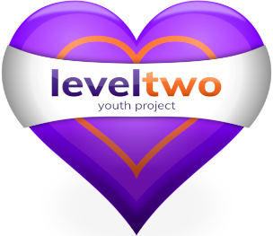

Policy Number 6

CONFIDENTIALITY POLICY

(Issue 9 – Revised July 2022)

Approved by Trustees__20th September 2022_______

Registered Charity Number: 1102380

Registered Address: 2nd Floor, 54 Cobbold Road, Felixstowe IP11 7EL

Confidentiality Policy

- All personal information will be treated as confidential. We define personal information as information which identifies someone by characteristics other than their first initial & surname only. This includes images protecting the identity of those who do not consent to photos.

- For service users – By confidentiality we mean that young people have a right to a service that is confidential to the Level Two staff and that outside agencies will only be contacted or referred to with a young person’s consent, except in the case of Safeguarding matters or illicit activity when consent may not be required (see Safeguarding Policy No. 3).

- Any issue of concern about a young person’s well-being will always be confidentially logged & shared internally if needed. An external referral will happen if the concern relates to safeguarding or emotional wellbeing.

- Any young person who wishes to see any written record kept about them, may do so by giving notice to the Project Manager, who will allow the named individual to view (but not remove, amend or copy) any such documents. (If any factual inaccuracies are identified – these are to be noted by the Project Manager and investigated accordingly.) These records will be kept for 7 years, after which they will be destroyed.

- Statistical information and session recordings will be kept for monitoring and evaluation purposes. These will be kept for not longer than 2 yrs.

- Information stored on computers and any written records are covered by Level Two’s Data Protection Policy (Number 21).

- Young people will be informed of our confidentiality policy through:

Sharing the main areas of the policy with young people through conversation & signing an agreement prior to a one-to-one Mentoring or Counselling. Regular reminders given verbally to young people in 1-1 conversations. Where a conversation takes place in another setting & a disclosure or hint of is made then the young person will also be made aware of our Policy. Level Two is required to work within the law, and Suffolk Safeguarding Children Board policy & procedures

- Staff, Volunteers & Trustees are requested to sign our Confidentiality statement. (See Appendix 1 & 2.)

