Felixstowe Youth Development Group

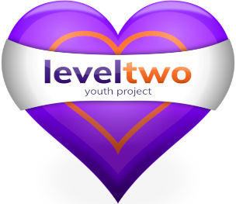

Policy Number 5

Smoking, Alcohol & Illegal Substance Policy

(Issue 10 – Revised April 2022)

Approved by Trustees on ___April 2022__________________

Registered Charity Number: 1102380

Registered Address: 2nd Floor, 54 Cobbold Road, Felixstowe IP11 7EL

Smoking, Alcohol & Illegal Substance Policy

The focus of this policy is on young people. (Staff issues are covered in Policy Number 17)

- Primarily to ensure the immediate and long-term well-being of the young people using Level Two premises and services.
- It is also important that the good name and integrity of Level Two, its staff and users be maintained.
- Level Two will have smoking, alcohol & illegal substance information available.

Smoking & Alcohol
- Tobacco, Vape or Alcohol in any form is not allowed to be consumed on Level Two’s premises. The only exception to this is that alcohol can be consumed at prearranged social functions, not open to Young People.

- Signs at the entrance to Level Two, in the stairwell and in the hub remind Young People of the rules that Level Two has regarding tobacco, vape, drugs and alcohol.

- Young people who choose to challenge this rule will be spoken to by a member of staff, and appropriate action will be taken. This will include the handing over of any such items for the duration of the session. The returning of items back to a young person is at the discretion of the Team on Session. Should a young person not hand over such items they must be asked to leave the session. Parents will be informed where necessary.

- On a trip or visit away from the Hub young people will be reminded of this rule. Staff will use their discretion in how to supportively manage young people who are struggling this rule on a trip. Parents will be informed where necessary.

- Any young person arriving at Level Two under the influence of alcohol will be offered support. If they are under the age of 16yrs an internal safeguarding log will be completed. Parents or guardians will be informed where appropriate.

- Appropriate action will be taken in consultation with the team on session & the Safeguarding Lead will be informed.

Illegal Substances
- Illegal substances are not allowed on Level Two premises. This includes recreational drugs, Energy Drinks for under 16’s & Alcohol for under 18’s.

- Young people who choose to challenge this rule will be spoken to by a member of staff, and appropriate action will be taken. This will include the confiscation of any such items. Should a young person not hand over such items they must be asked to leave the session.

