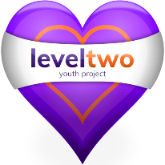Level Two’s 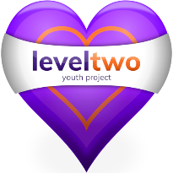Children in Need
Photography competition fundraiser for 2020.
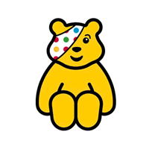
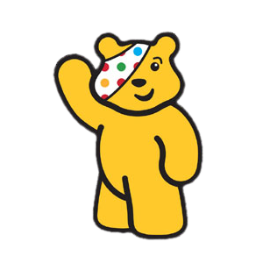
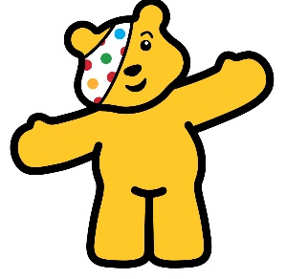
Please support Children in Need by entering our photo competition.
3 categories: 1. Animal, 2. Happiness, 3. Natural form
You can enter 1 photo for each category.
The entrance fee is £1 per photo.
All of this money will go to Children in Need.
The winner in each category will have their photos used in Level Two promotions, so it will appear on our Instagram, Facebook and Website, with the photo credited to the winner.
Please send your entries to Emma,
via WhatsApp on 07444 819 353

Details on how to pay will be given on submission of your photos.

This competition is open to all young people in Felixstowe and the surrounding area, from the age of 7 to 25 years old.

