A big “thank you” from Level Two Youth Project to the

BEACH HOUSE and KW AUTOS

for their support this summer.

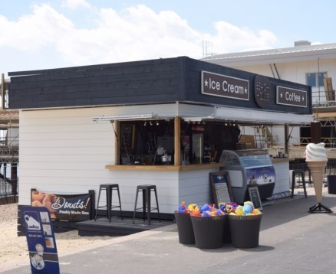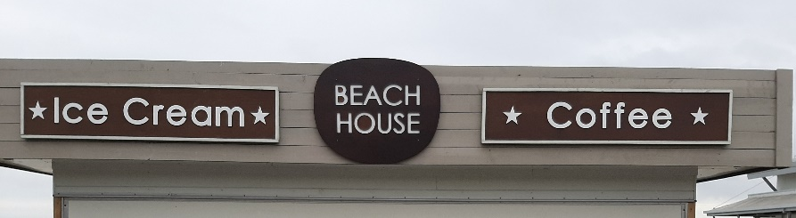

It is greatly appreciated by us all xx