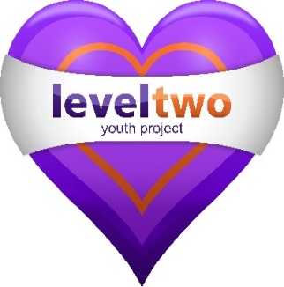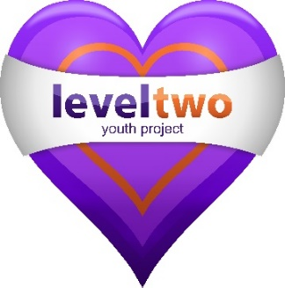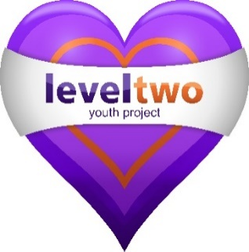
LEVEL TWO YOUTH PROJECT

STARTING THURSDAY 1st OCTOBER 2020

AT THE GRANGE FARM TESCO
(Adjacent to Ropes Drive, opposite Fentons Way junction.)
EVERY THURSDAY EVENING, 6pm – 7.30pm
--------------------
Do come along for a chat, & a free hot chocolate,
we would love to meet you!!
Come & tell us more about life for young people living in Kesgrave.
---------------------
Our offer - C-cards/condoms – Conversation – Information & Advice on Topics relevant to young people –
Competitions with prizes

--------------------
For all Young People in Yr.10+

Note– If it is raining or extreme weather, sessions may be cancelled
--------------------

To find out more about Level Two Youth Project please visit
our Website www.leveltwo.org
or find us on Facebook
Or call 07724356723

