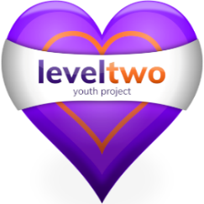

The Youth Hub at the Heart of the Community
Providing youth services for all 7-25 year olds
in Felixstowe and the surrounding area
Felixstowe Youth Development Group

Registered Charity No. 1102380 Registered Company No. 04125056

LEVEL TWO MENTORING

Dear Family,

This is a really worrying time for us all. If you feel it would be helpful to have a video call or a phone call once a week to support you in any way then please do get in touch. Our Mentoring offers a confidential one-to-one service, providing support to young people age 7-25 in Felixstowe. If you are struggling with something, worried, confused or just need support or someone to talk to, we can help! We don’t promise to solve problems, but we do promise to listen and support you on however we can.

To find out more please contact: -

Kirsty (07392964461) kirstycoldwelllevel2@gmail.com

Shez (07724356723) shezhopkinslevel2@gmail.com

Or visit www.leveltwo.org

Facebook @leveltwoyouthproject

Felixstowe Youth Development Group
Level Two Youth Project (above Tesco in town centre) 2nd Floor,
54 Cobbold Road, Felixstowe, IP11 7EL

