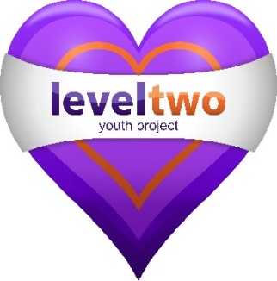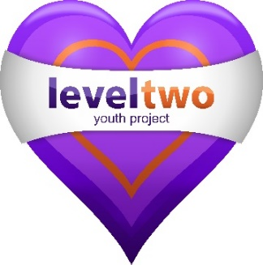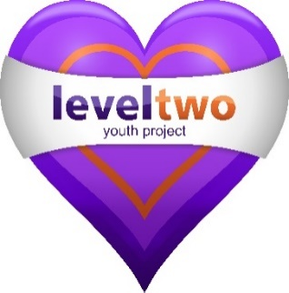
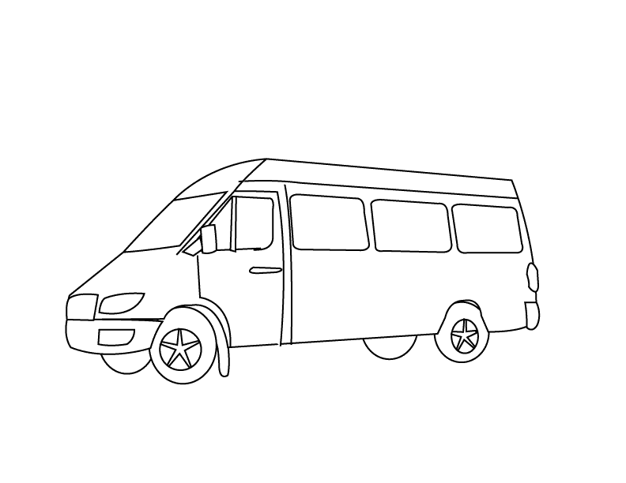
LEVEL TWO WILL BE OUT AND ABOUT IN OUR MINIBUS, DOING DETACHED WORK OVER THE SUMMER HOLIDAYS FOR 5 WEEKS!!!

DO COME ALONG FOR SOME FUN ACTIVITIES OR EVEN JUST FOR CATCH UP OR A CHAT, WE WOULD LOVE TO SEE YOU.

WEEK COMMENCING MONDAY THE 27TH JULY 2020
FROM AGE 7 YEARS AND UP
(Please see below for days, locations and times)

Day | Location | Time
Monday | Brackenbury Cliff Tops | 2pm – 4pm
Tuesday | Langer Park | 2pm – 4pm
Wednesday | Pier Area | 6pm – 8pm
Thursday | Skate Park / Morrison’s Field | 6pm – 8pm
Friday | Pier Area – YAS  (Young Adult Session Years 11+) | 6pm – 8pm

