For Young People, Parents, Guardians & Teachers

How do you feel about

returning to school ?

Are you worried about any of the following or maybe know someone who is?

Leaving home Safety of being outside or at school

School work Mixed Classes The Unknown?

Change in routine Relationship issues with friends, family or others

Sad Anxious Tired Alone

Irritable Tearful Angry Confused

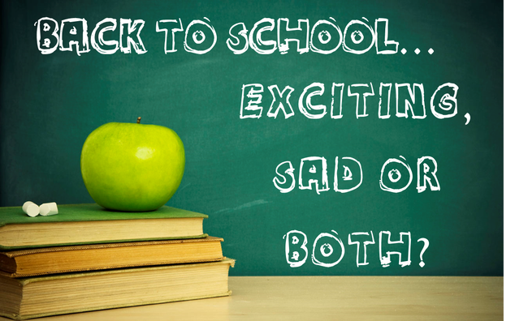

Level Two is a local charity supporting young people aged 7 to 25 years.

We understand this has been a very difficult time for everyone especially our young people during this pandemic. Our BACP registered Counsellor is offering a new service. This is aimed at all young people going back to school from year 6 to year 12 (Ages 11yrs to 18yrs).

Its focus is on young people that are worried or concerned about the recent events and returning back to school.

Young people can be referred or you can refer yourself, if accepted you will be offered 4 Skype sessions that will last 30 minutes each (Instructions on how to use Skype will be sent, if needed). Followed by 2 sessions at school once you return, face to face. Supporting the young person through the transition of returning back to school on a regular basis.

Please complete the form below for contact to be made:

Name of Young Person………………………………………………………………………………….

Age of Young Person……………………………………………………………………………………..

School year in September ………… Name of School……………………………………….

Contact Number……………………………………………………………………………………………

Email Contact……………………………………………………………………………………………….

Name of parent/guardian…………………………………………………………………………….

Number of parent/guardian………………………………………………………………………..

Are you happy for your parent/guardian to be contacted………………..….…..

Name and contact if you have referred the YP…………………………………………..

Please send your completed form to: lisamileslevel2@gmail.com