***Felixstowe Youth Development Group***

**2nd Floor, 54 Cobbold Road, Felixstowe, Suffolk, IP11 7EL**

**Tel: (01394) 272521 Email:** [**fydglevel2@btconnect.com**](mailto:fydglevel2@btconnect.com)

**www.leveltwo.org**

***Registered Charity No. 1102380***

***Registered Company No. 04125056***

Please come along and join Level Two for a wine tasting evening at the Wine Boutique, Felixstowe on Tuesday the 28th January 2020 at 7pm - 9pm, £15.00 per person, we look forward to seeing you all there.

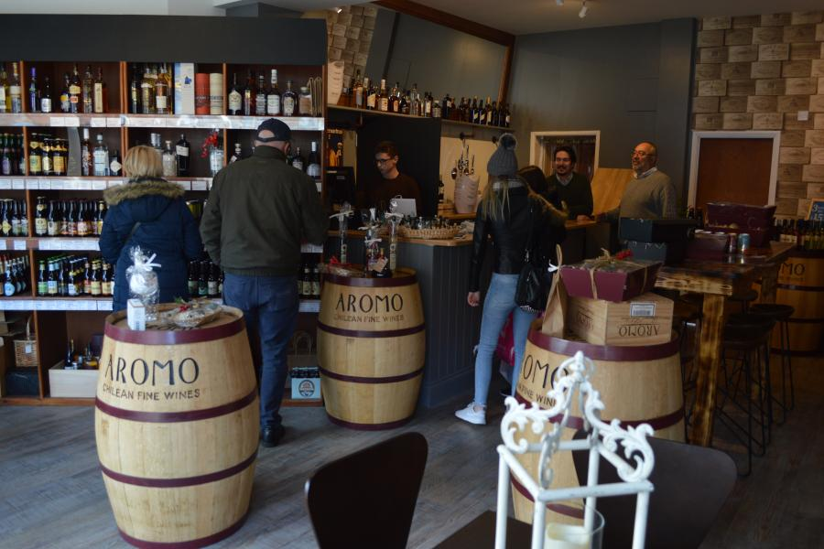

There are limited tickets available so please book yours as soon as possible to avoid any disappointment.