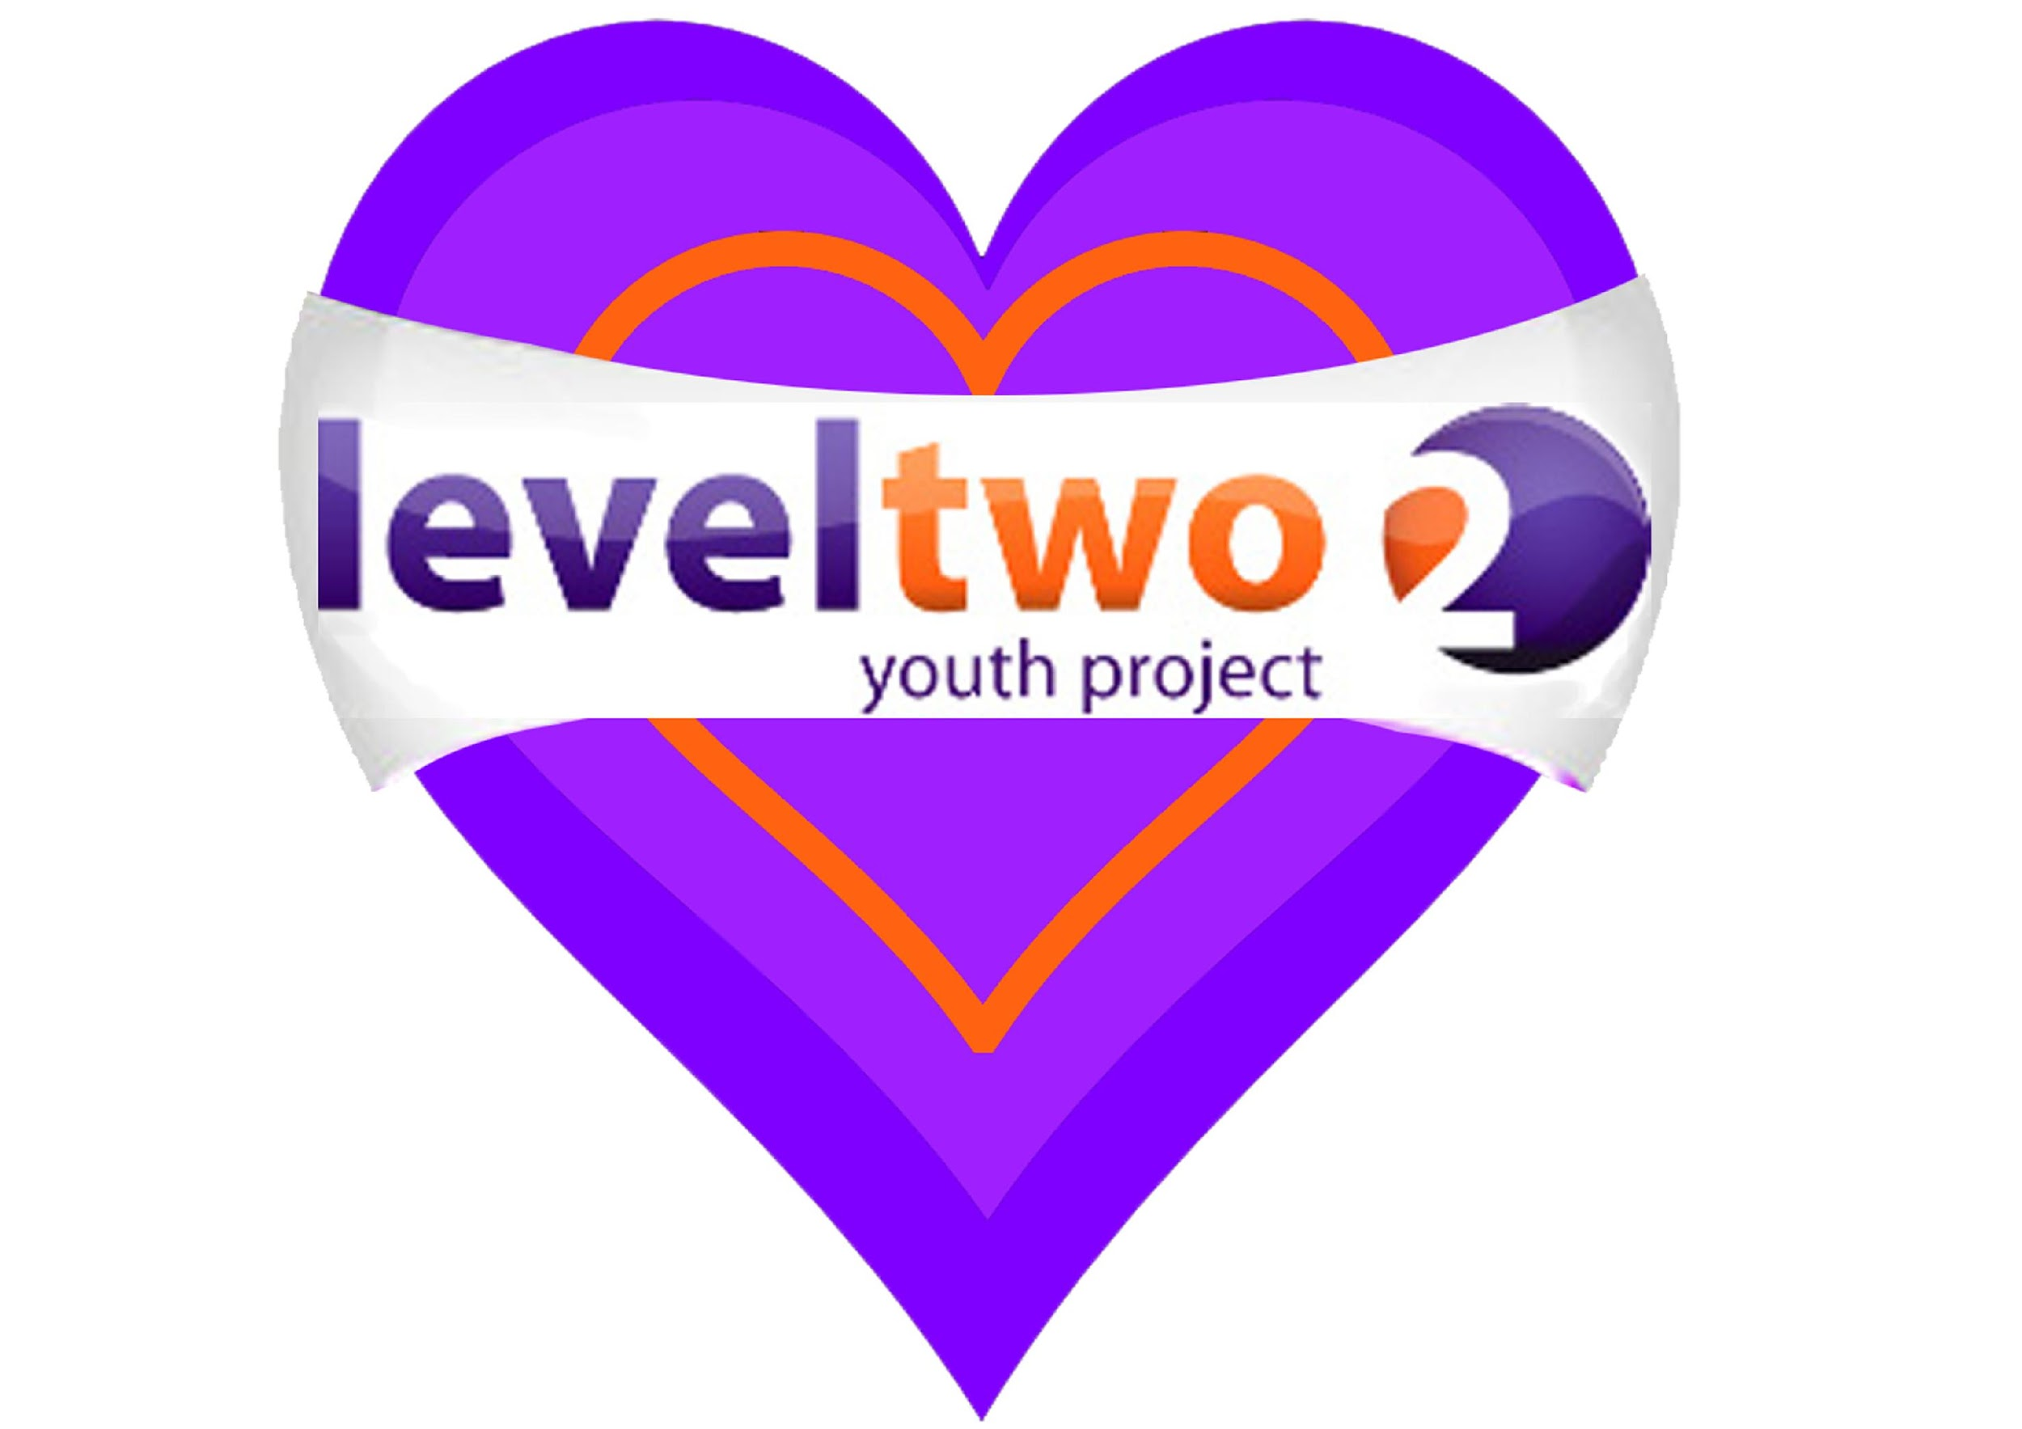
Level Two
welcomes young people from Years 4, 5 and 6 to
Kirton Rec
On Thursdays from 12th September 2019
4-5pm (term time only)
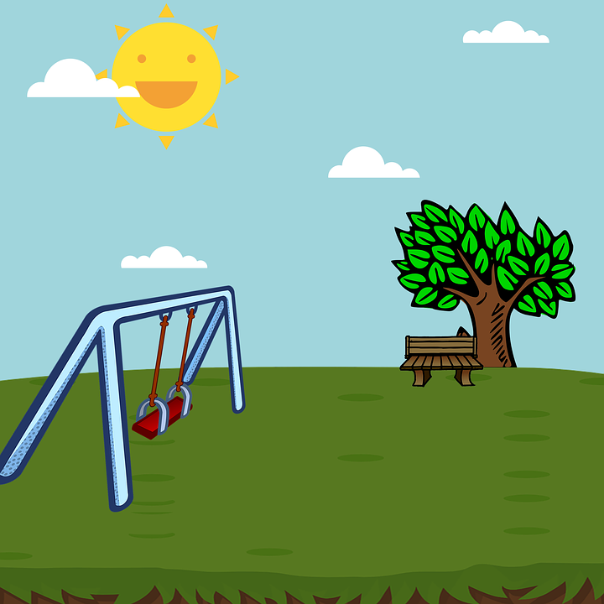

Come and play games, have fun and make new friends!
There will be snacks too!
Registration required so please bring a parent or guardian along.
For more details please contact Level Two on (01394) 272521
Or email: fydglevel2@btconnect.com

