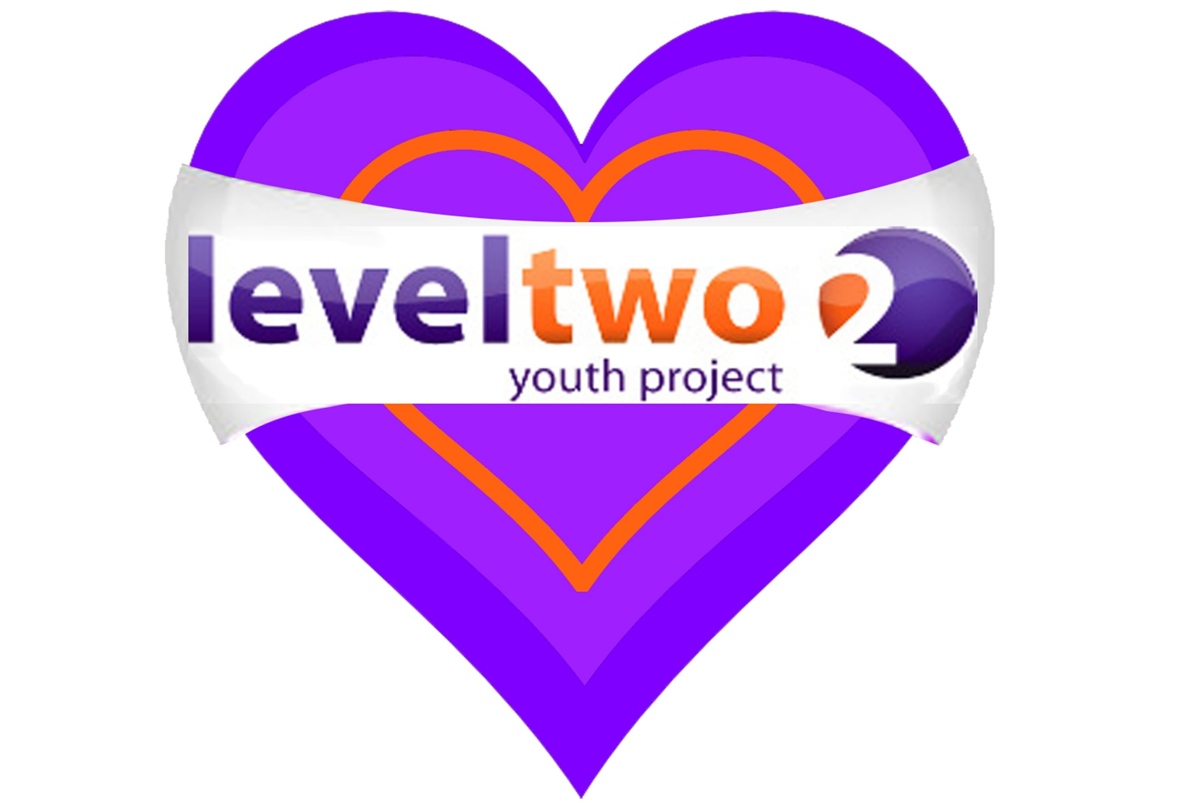

**September to December 2019 (Term Time Only)**

**Level Two Youth Project Weekly Activities**

**MONDAY**  4pm – 5.30pm GIRLS GROUP – School Years 6-11 at Level Two.

**TUESDAY**  4pm - 5.30pm YEAR 7 & 8 Level Two.

**WEDNESDAY**  LGBTQ - For more information contact Shez on 07724356723.

**FXA** - G87 1pm-1.30pm C-CARD drop-in & sexual health advice.

AFTER SCHOOL DROP IN at **FXA** 2.50pm-3.15pm (IN THE ATRIUM).

**THURSDAY** 4pm-5.30pm BOYS GROUP – School years 6-11 at Level Two.

**4pm–5pm Kirton Rec Group- School Years 4, 5 & 6 (At Kirton Rec)**

6.30pm-8pm YEAR 9 & 10 at Level Two.

LGBTQ Drop in at **FXA** contact Shez as above.

**FRIDAY** 6.30pm-8.00pm **Y**OUNG **A**DULT **S**ESSION Year 11+ at Level Two.

**SATURDAY 10.30am-12 noon - Open Access – School Years 6-11.**

**One to one mentoring and counselling available – by referral.**

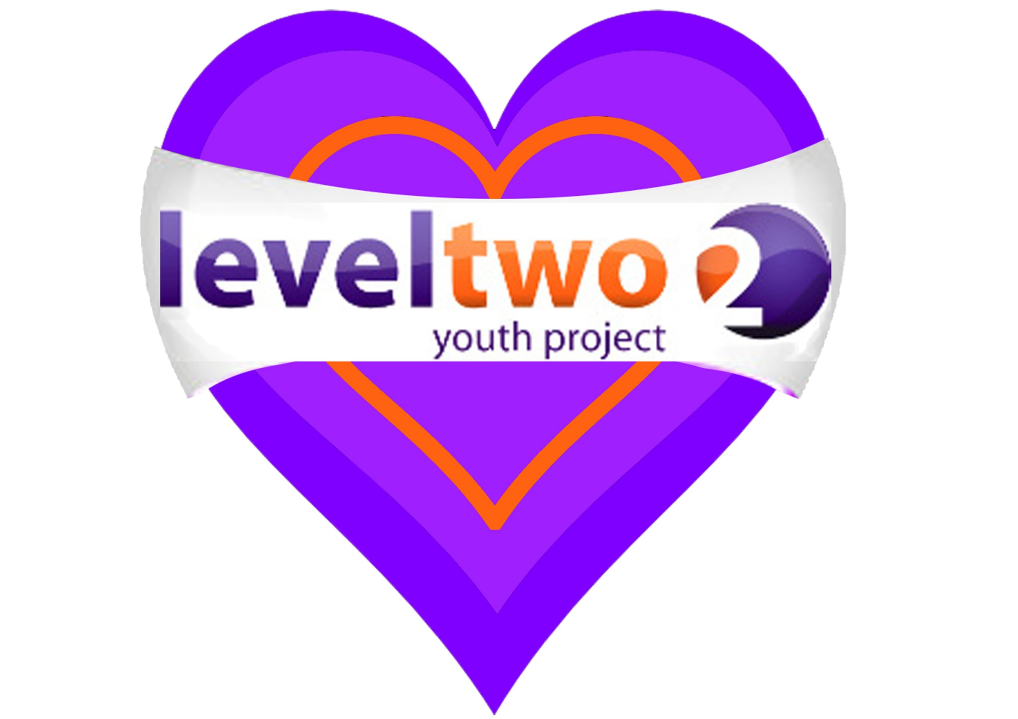





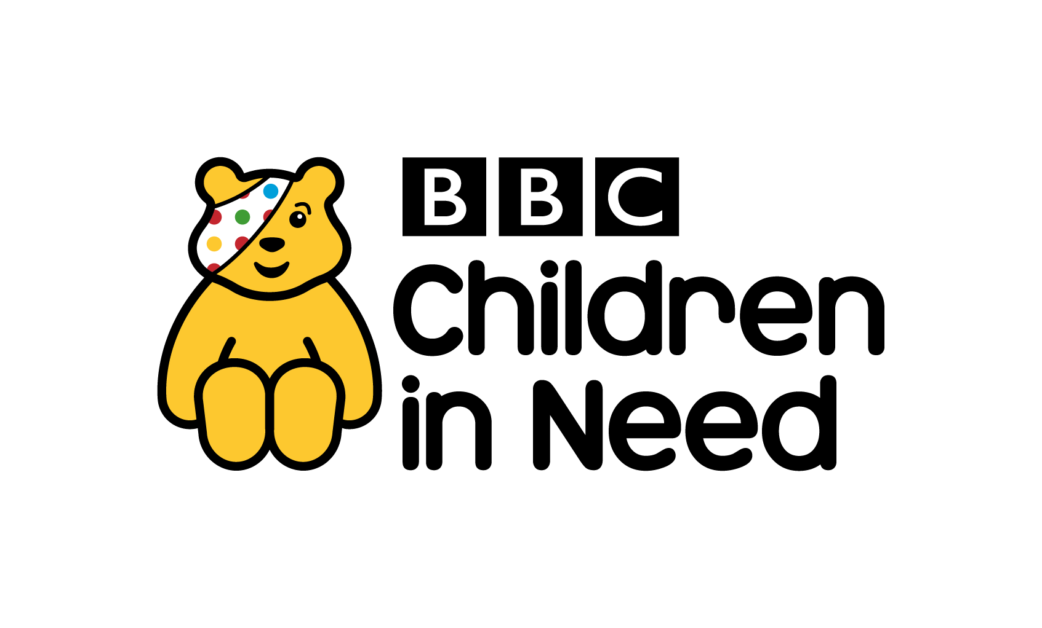



**ACTIVITIES**

**POOL**

**WII**

**XBOX**

**TABLE TENNIS**

**AIR HOCKEY**

**MUSIC**

**COOKING**

**COMPUTERS**

**TRIPS**

**CHILL OUT AREA**

**ART & CRAFT**

**CRAFT TOPIC ACTIVITIES**

At Level Two Youth Hub (Above Tesco)

Level Two Youth Project is a charity in Felixstowe for all young people. To find out more about us join our facebook page, visit our website [www.leveltwo.org](http://www.leveltwo.org) or Tel: 01394 272521 email: fydglevel2@btconnect.com

***‘We are committed to safeguarding the welfare of all young people’***