Open sessions
From Year 6 Plus
Level Two sessions will run every
Tuesday & Thursday @
2pm till 4pm
Over the School Holidays
Starting from the 30th July
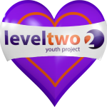
until the 29th August 2019

