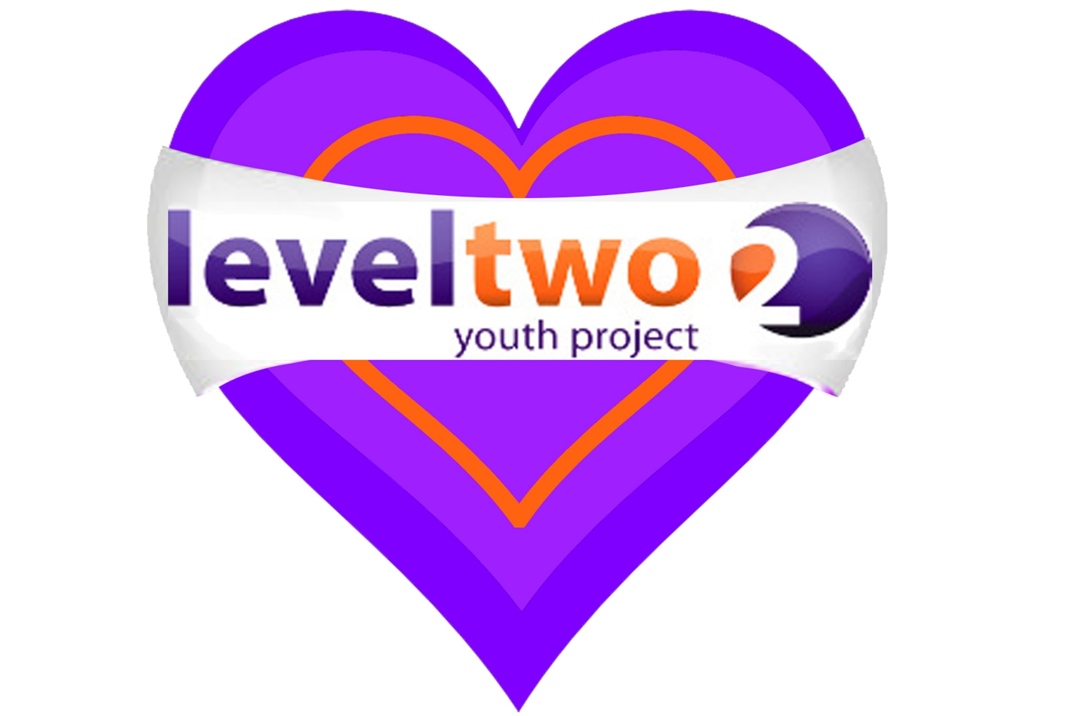

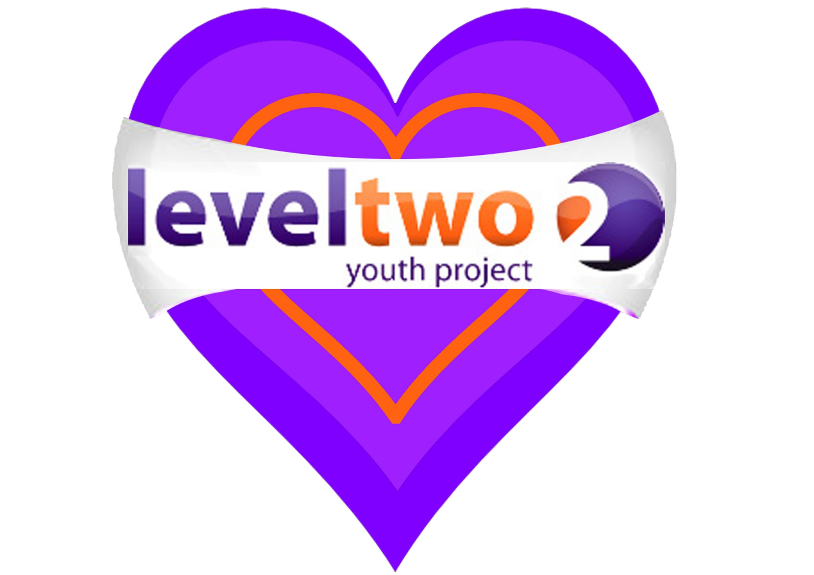





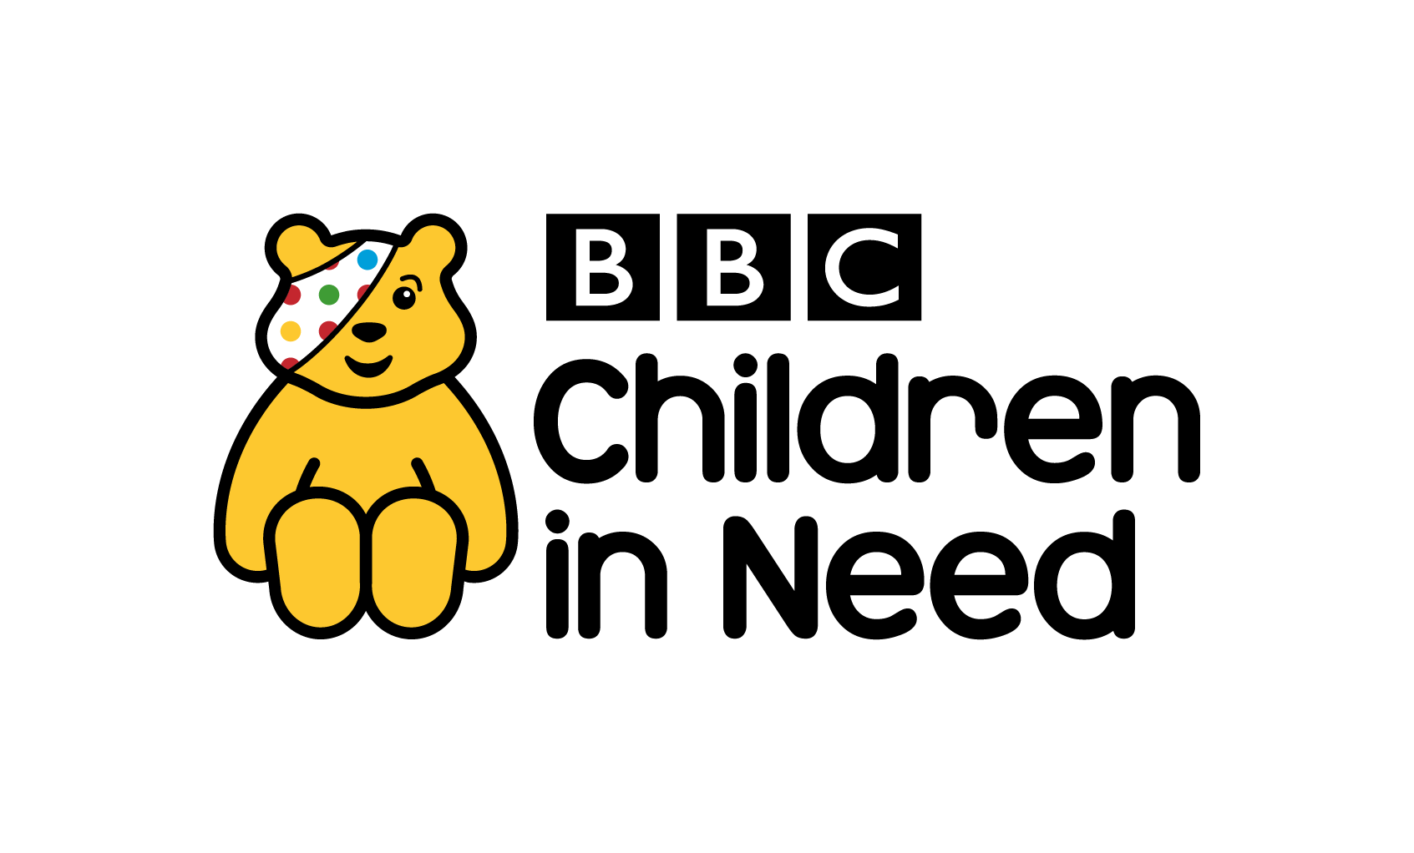



**ACTIVITIES**

**POOL**

**WII**

**XBOX**

**TABLE TENNIS**

**AIR HOCKEY**

**MUSIC**

**COOKING**

**COMPUTERS**

**TRIPS**

**CHILL OUT AREA**

**ART & CRAFT**

**CRAFT TOPIC ACTIVITIES**

**May to July 2019**

**MONDAY**  4pm – 5.30pm GIRLS GROUP – School Years 6-11 at Level Two.

**TUESDAY**  4pm - 5.30pm YEAR 7 & 8 Level Two

**WEDNESDAY**  1pm-1.30pm C-CARD drop-in & sexual health advice (Rm G87 FXA)

2.50pm-3.15pm AFTER SCHOOL DROP IN at FXA (IN THE ATRIUM).

**THURSDAY** Lunchtime LGBTQ Drop in at FXA

4pm-5.30pm BOYS GROUP – School years 6-11 at Level Two.

6.30pm-8pm YEAR 9 & 10 at Level Two

6.30pm-8pm DETACHED YOUTH WORK (Various locations)

**FRIDAY** 7pm-8.30pm YOUNG ADULT SESSION at Level Two

**One to one mentoring and counselling available – by referral.**

**LGBTQ support group – more information from Shez, Mobile. 07724356723**

**Weekday support** for young people 16-25s - Information, Advice, and

Guidance on many issues, including NEET, emotional support, sexual health, C-Cards – please telephone to make an appointment.

At Level Two Youth Hub (Above Tesco)

Level Two Youth Project is a charity in Felixstowe for young people age 7-25.

To find out more about us join our facebook page,visit our website [www.leveltwo.org](http://www.leveltwo.org) or Tel: 01394 272521

***‘We are committed to safeguarding the welfare of all young people’***