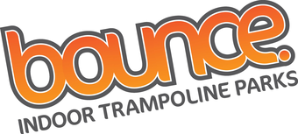
AND STOP AT
Tuesday 20th August 2019
Meet @ Level Two @ 4pm, return at 7.30pm
Money required for KFC, socks included in price.
£15
To book a place call Level Two on 01394 272521
