**CONGRATULATIONS ON**

**YOUR GRADUATION**

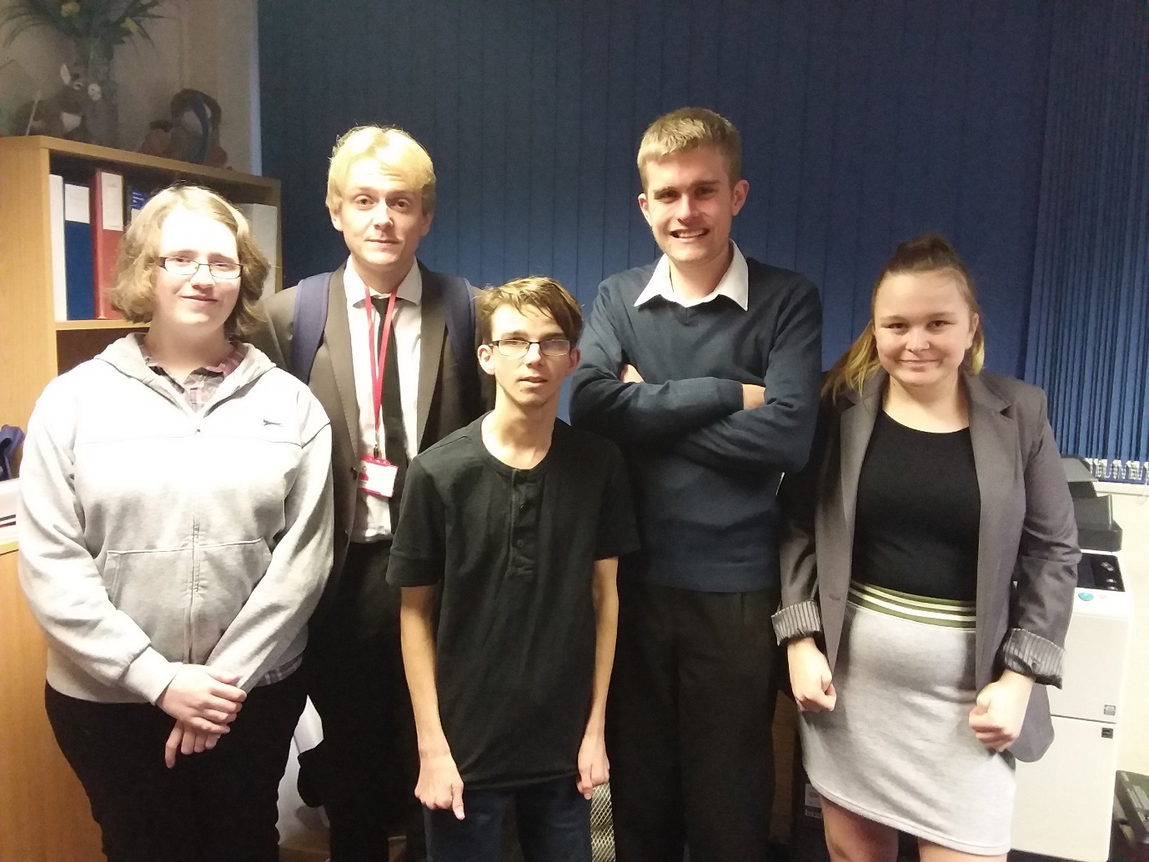

**Hope you have enjoyed your 12 week course with**

**The Princes Trust.**

**With best wishes from**

**Shez, Wendy, Kirsty &**

**all at Level Two**