
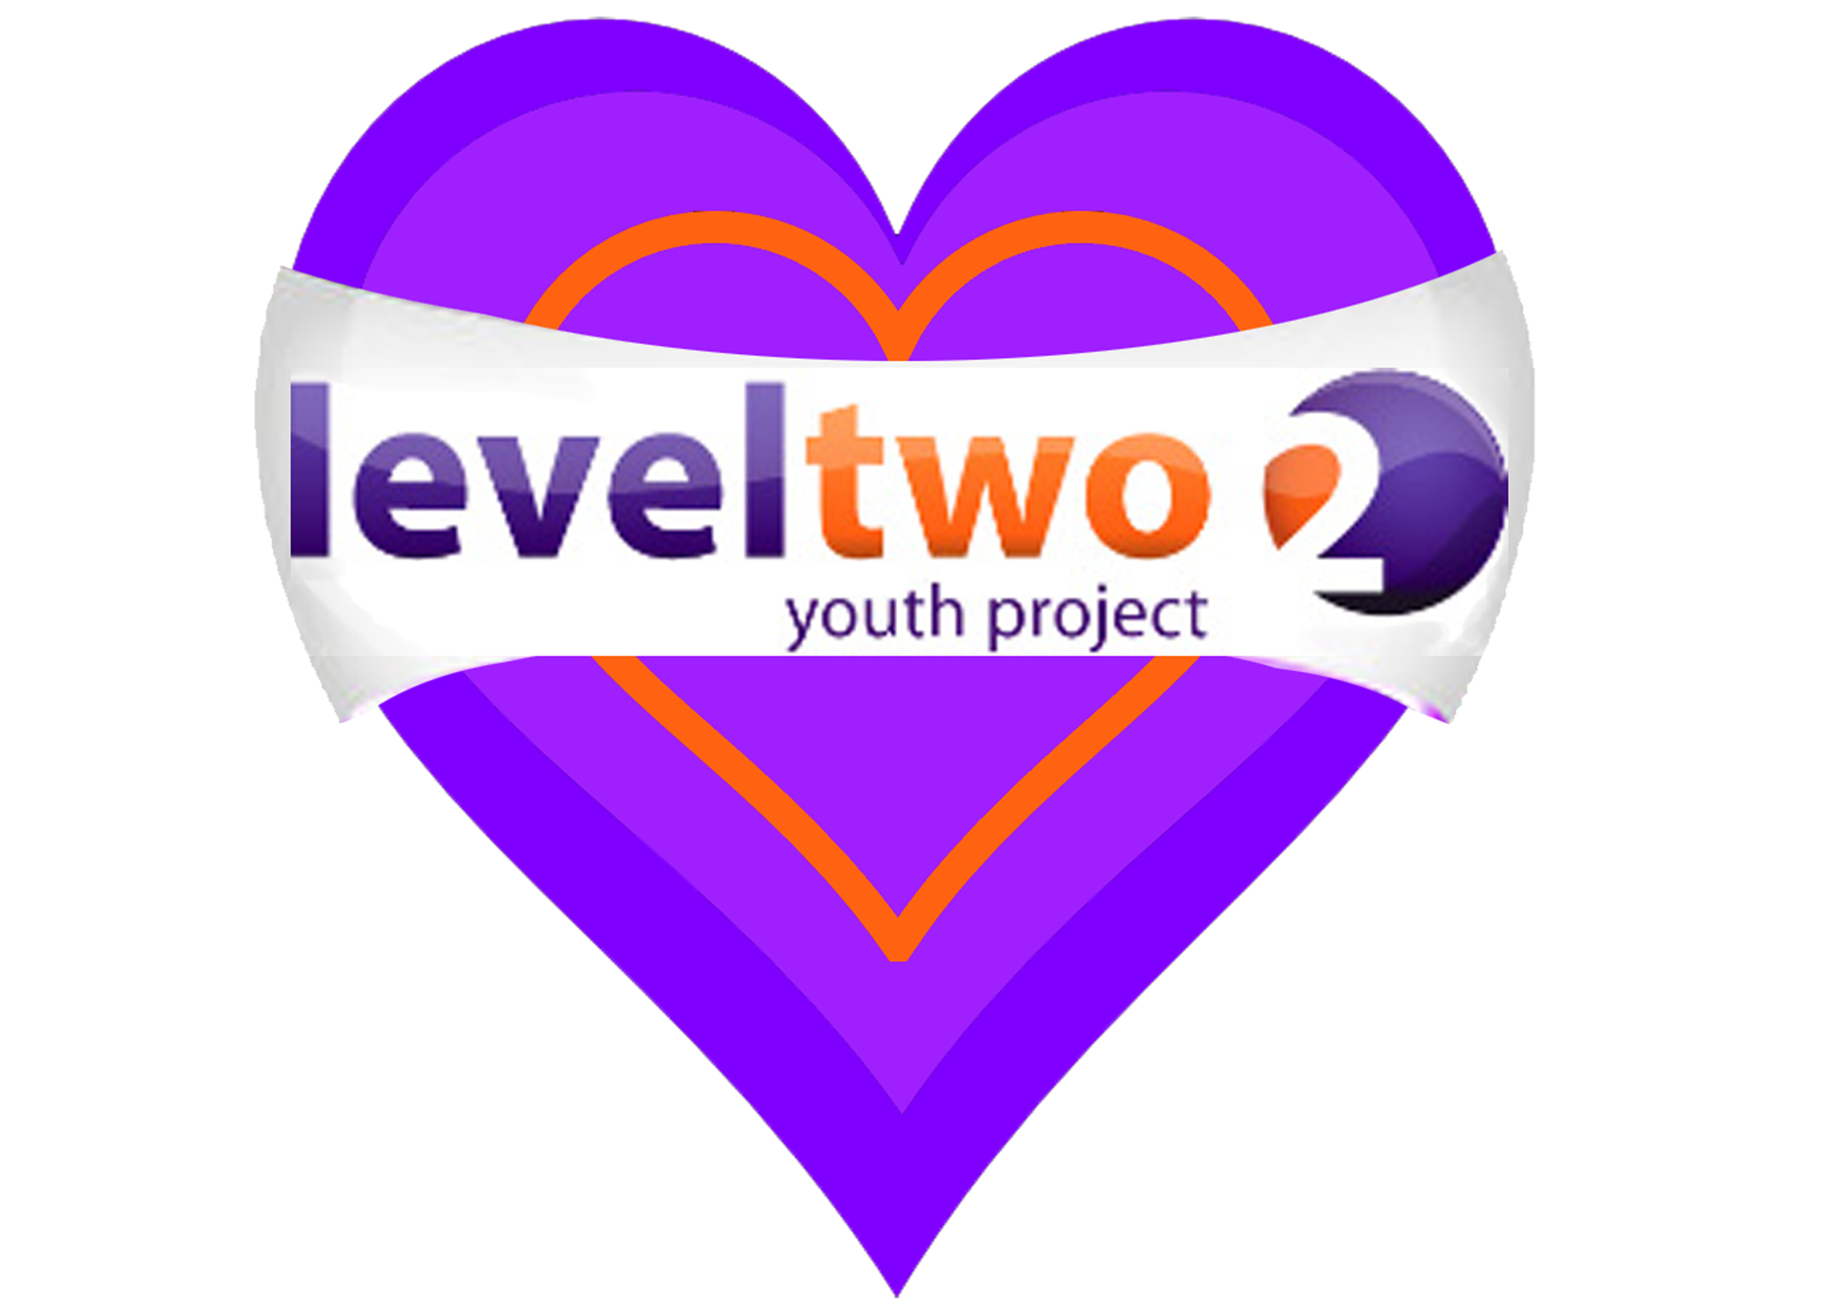


SEPTEMBER – OCTOBER

HALF TERM 2016

NEW PROGRAMME
(Term-Time Only – Commencing 5th Sept)

MONDAY LUNCH-TIME IN THE ATRIUM DROP IN AT FELIXSTOWE ACADEMY TUESDAY 4.00 – 5.30 P.M. YEAR 7s
7.00 – 8.30 P.M. GIRLS ZONE – School Years 7-11
WEDNESDAY 4.00 – 5.30 P.M. YOUNG CARERS
THURSDAY 4.00 – 5.30 P.M. SCHOOL YEAR 8 & 9
7.00 – 8.30 P.M. BOYSZONE – School Years 7-11
FRIDAY 8.00 – 9.30 P.M. SCHOOL YEARS 10-14

TUESDAYS & THURSDAYS 10 A.M – 12 MIDDAY

Open for Young People age 16-25 to drop in for Information, Advice, and Guidance on many issues, including NEET, job search, benefits, housing.

At Level Two Youth Hub (Above Tesco)

Level Two Youth Project is a charity in Felixstowe for young people age 10-25.

To find out more about us join our facebook page,

visit our website www.leveltwo.org or Tel: 01394 272521
‘We are committed to safeguarding the welfare of all young people’

