
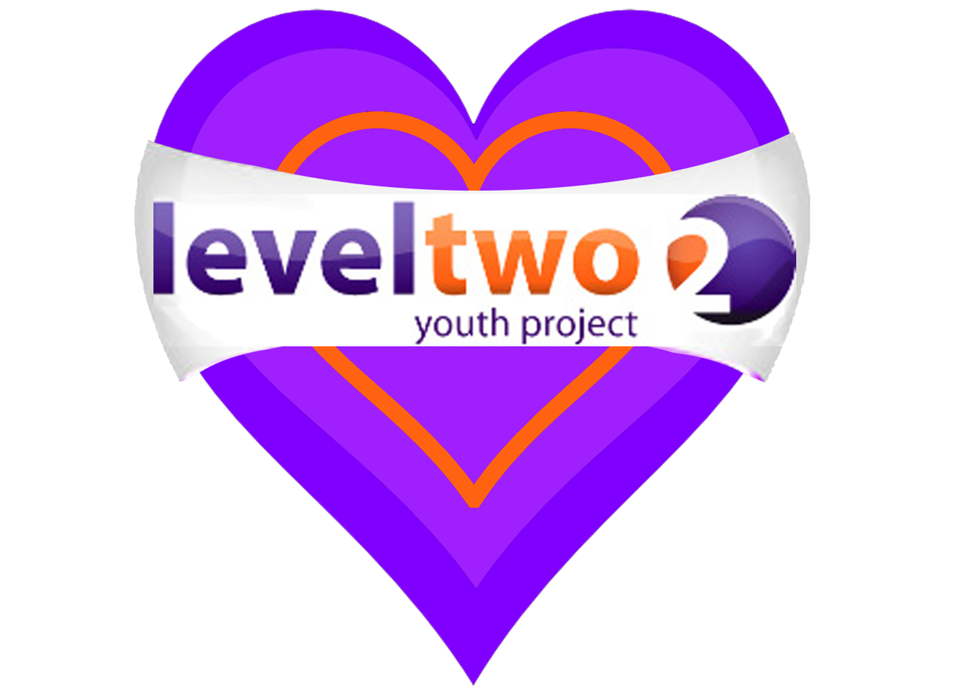


APRIL 13- MAY 22nd 2015

NEW PROGRAMME
(after Easter – up until May Half-term)

TUESDAY 4.00 – 5.30 P.M. SCHOOL YEARS 7&8 OPEN SESSION
7.00 – 8.30 P.M. GIRLS ZONE – School Years 7-11

THURSDAY 4.00 – 5.30 P.M. SCHOOL YEAR 6
Transition to High School

FRIDAY 8.00 – 9.30 P.M. SCHOOL YEARS 9-13

MONDAY TO THURSDAY 10 A.M – 12 MIDDAY

Open for Young People age 16-25 to drop in for Information, Advice, and Guidance on many issues, including NEET, job search, benefits, housing,

At Level Two Youth Hub (Above Tesco)

Level Two Youth Project is a charity in Felixstowe for young people age 10-25

To find out more visit our website www.leveltwo.org or Tel: 01394 272521

